**FEAST HUB**

**(Food Delivery Website)**

**A PROJECT REPORT**

**for**

**Major Project (KCA-451)**

**Session (2023-24)**

**Submitted by**

**NISHANT TYAGI**

**(2200290140100)**

**MAYANK SINGH**

**(2200290140090)**

**Submitted in partial fulfilment of the**

**Requirements for the Degree of**

**MASTER OF COMPUTER APPLICATION**

**Under the Supervision of**

**Mrs. Monika Kansal**

### (Assistant Professor)



**Submitted to**

**Department OF Computer Applications**

**KIET Group of Institutions, Ghaziabad**

**Uttar Pradesh-201206**

**(2023-2024)**

**CERTIFICATE**

Certified that **Nishant Tyagi and Mayank Singh have** carried out the project work having **Food Delivery Website** (**Major Project-KCA-451**) for **Master of Computer Application** from Dr .A.P.J. Abdul Kalam Technical University (AKTU**) (**formerly UPTU), Lucknow under my supervision. The project report embodies original work, and studies are carried out by the student himself and the contents of the project report do not form the basis for the award of any other degree to the candidate or to anybody else from University.

**Date: Nishant Tyagi**

**University Roll. No: 2200290140100**

**Mayank Singh**

**University Roll. No:**

**2200290140090**

This is to certify that the above statement made by the candidate is correct to the best of my knowledge.

Date:

**Mrs. Monika Kansal Dr. Arun Kumar Tripathi**

**Assistant Professor Head**

**Department of Computer Applications Department of Computer Applications**

**KIET Group of Institutions, Ghaziabad KIET Group of Institutions, Ghaziabad**

**ABSTRACT**

Luxuriate your taste buds with our seamless food delivery platform, where culinary delights are just a click away. Discover a diverse array of delectable cuisines from local favourites to international treasures, all delivered to your doorstep quickly and conveniently. Our user-friendly interface ensures a hassle-free ordering experience, while our commitment to quality ensures that every bite is a celebration of flavour. Elevate your dining experience with our food delivery website, where satisfaction is always on the menu.

An Online Food Ordering System is proposed here which simplifies the food ordering process. The proposed system shows an user interface and update the menu with all available options so that it eases the customer work. Customer can choose more than one item to make an order and can view

order details before logging off. The order confirmation is sent to the customer. The order is placed in the queue and updated in the database and returned in real time. This system assists the staff to

go through the orders in real time and process it efficiently with minimal errors.

**ACKNOWLEDGEMENTS**

Success in life is never attained single-handedly. My deepest gratitude goes to my project supervisor, **Mrs. Monika Kansal** for her guidance, help, and encouragement throughout my project work. Their enlightening ideas, comments, and suggestions.

Words are not enough to express my gratitude to Dr. Arun Kumar Tripathi, Professor and Head, the Department of Computer Applications, for her insightful comments and administrative help on various occasions.

Fortunately, I have many understanding friends, who have helped me a lot on many critical conditions.

Finally, my sincere thanks go to my family members and all those who have directly and indirectly provided me with moral support and other kind of help. Without their support, completion of this work would not have been possible in time. She keep my life filled with enjoyment and happiness.

**Nishant Tyagi**

**University Roll. No: 2200290140100**

**Mayank Singh**

**University Roll. No: 2200290140090**

**TABLE OF CONTENTS**

Page Number

Certificate ii

Abstract iii

Acknowledgement iv

Table of Contents v

List of Tables vi

List of Figures vii

Chapter 1: Introduction  1 - 3

1.1 Project description  1

1.2 Project Scope  1

1.3 Hardware / Software used in Project  2

Chapter 2: Feasibility Study  4 - 6

2.1 Technical Feasibility 4

2.2 Operational Feasibility 4

2.3 Economical Feasibility 5

Chapter 3: Database Design  7 - 20

3.1 E-R Diagram 7

3.2 Data Flow Diagram  10

3.3 Use Case Diagram 18

Chapter 4: Design 21 - 32

Chapter 5: Discussion 33 – 34

5.1 Challenges Faced 33

5.2 Decisions Made 33

5.3 Potential Improvements 34

5.4 Future Enhancements 34

Chapter 6: Testing 35 - 38

5.1 Unit Testing 35

5.2 Integrating Testing 36

5.3 System Testing 37

Chapter 6: Conclusion 39 – 33

7.1 Technical Aspects 39

7.2 Financial Consideration 39

7.3 Operational Viability 40

7.4 Risk Analysis and Mitigation 40

7.5 Recommendation 41

Chapter 7: Bibliography 42

**LIST OF TABLES**

**Table No. Name of Table Page No.**

1.1 Hardware Requirements 2

1.2 Software Requirements 2

**LIST OF FIGURES**

**Figure No. Name of Figure Page No.**

3.1 ER Diagram 9

3.2 0 level DFD 9

3.3 1st level DFD 13

3.4 2nd level DFD (a) 16

3.5 2nd level DFD (b) 16

3.6 Use Case Diagram 19

4.1 Login Module 21

4.2 Register Module 22

4.3 Home Page 23

4.4 Categories 24

4.5 Add Cart 25

4.6 Order Status 26

4.7 Profile Management 27

4.8 Payment Module 28

4.9 Database Schema 29

4.10 Food Collection 30

4.11 Order Collection 31

4.12 User Collection 32

**CHAPTER 1**

**INTRODUCTION**

* 1. **Project Description**

An The academic project involves developing a comprehensive food ordering website designed to streamline the process of ordering meals online. The website will feature a user-friendly interface, enabling customers to browse menus, customize orders, and make payments seamlessly. Key functionalities will include user registration, restaurant listings, real-time order tracking, and a secure payment gateway. The project will incorporate responsive design to ensure compatibility across various devices, enhancing user accessibility. Additionally, the system will utilize a robust backend to manage user data, order histories, and restaurant profiles efficiently. The project aims to provide a practical solution to modern food ordering challenges, emphasizing usability, security, and reliability. By integrating these features, the website will offer a convenient platform for customers and restaurants, improving the overall dining experience. The development process will also provide valuable insights into web development, database management, and e-commerce integration for the academic team..

In this project Technology Used

1. **Front End Technology:**

* React JS

1. **Back-End Technology:**

* Node JS
* Express JS

1. **Database:**

* MongoDB
  1. **Project Scope**

To design and implement a user-friendly online food ordering system that allows customers to browse menus, place orders, and make payments from various local restaurants.

**Scope:**

1. **User Interface:**
   * Develop a responsive and intuitive user interface accessible on both desktop and mobile devices.
   * Implement features such as user registration, login, and profile management.
   * Provide restaurant listings with detailed menus, prices, and images.
2. **Order Management:**
   * Enable customers to add items to a cart, customize orders, and specify delivery instructions.
   * Include real-time order tracking and status updates.
3. **Payment System:**
   * Integrate secure payment gateways supporting multiple payment methods (credit/debit cards, digital wallets).
   * Implement order confirmation and e-receipt generation.
4. **Restaurant Interface:**
   * Provide restaurants with an admin panel to manage their menu, prices, and special offers.
   * Enable restaurants to receive, confirm, and track orders.
5. **Backend:**
   * Design a robust backend system to handle user data, order processing, and inventory management.
   * Ensure data security and privacy compliance.
6. **Testing and Quality Assurance:**
   * Conduct comprehensive testing to identify and resolve bugs.
   * Ensure the system meets performance, usability, and security standards.

**Deliverables:**

* Fully functional food ordering website.
* User and technical documentation.
* Final project report and presentation.

**Timeline:** The project will be completed over a 12-week period, with milestones for planning, development, testing, and final deployment.

This project aims to streamline the food ordering process, enhance user experience, and support local restaurants through efficient order management.

* 1. **Hardware/Software Used**
     1. **Hardware Requirements:**

Tabel 1.1: Hardware Requirements

|  |  |
| --- | --- |
| Processor | i3 processor or more |
| RAM | 4GB or more |
| Hard Disk | 40GB OR MORE SSD |
| Window | Window 8 or higher |

* + 1. **Software Requirements:**

Tabel 1.2: Software Requirements

|  |  |
| --- | --- |
| Database | MongoDB |
| Server | Node Js |
| IDE | Vs Code |

In summary, introduction of the academic project on a food ordering website outlines the development of an online platform designed to streamline the food ordering process for customers and restaurants. This project aims to create a user-friendly interface that allows users to browse menus, place orders, and make payments efficiently. Additionally, it seeks to enhance operational efficiency for restaurants by automating order management and providing real-time updates. The system integrates modern web technologies to ensure responsiveness and reliability. Ultimately, this project addresses the growing demand for convenient, digital food ordering solutions in the contemporary, fast-paced lifestyle.

The important thing is to choose technologies that you are comfortable with while keeping performance, scalability and security in mind.

**CHAPTER 2**

**FEASIBILITY STUDY**

Building a food ordering website requires careful consideration of technical, financial and operational feasibility.

The purpose of this feasibility study is to assess the viability and potential success of the proposed food ordering website project. The project aims to replicate the functionality and features of the existing Amazon platform. This study evaluates the technical, operational, economic, and scheduling aspects to provide stakeholders with comprehensive insights into the feasibility of the project.

The food ordering website project involves developing a web platform that mirrors the key features of the original food ordering website, including product listings, user accounts, ordering cart functionality, payment processing, and order management. The project aims to provide a similar user experience while incorporating potential enhancements to differentiate it from the original platform.

**2.1 Technical Feasibility**

Developing a food ordering website involves assessing the technical requirements and resources available to complete the project. The primary components include:

1. **Technology Stack**: The project will utilize a robust technology stack comprising HTML, CSS, JavaScript for the front end, and Node.js or Python (Django/Flask) for the back end. A relational database like MySQL or PostgreSQL will store user data, orders, and menu items.
2. **Development Tools and Platforms**: Development will be executed using platforms such as GitHub for version control, Visual Studio Code for coding, and Heroku or AWS for deployment.
3. **Team Expertise**: The development team consists of individuals proficient in web development, including full-stack developers, UI/UX designers, and database administrators. Their combined experience will ensure the project meets industry standards and best practices.
4. **System Integration**: The website will integrate third-party APIs for payment processing (e.g., Stripe, PayPal) and geolocation services (e.g., Google Maps API) to enhance user experience and functionality.
5. **Scalability and Security**: The website will be designed with scalability in mind, using cloud services to handle increased traffic and data load. Security measures, including SSL certificates, data encryption, and secure user authentication, will be implemented to protect user data and transactions.

**2.2 Operational Feasibility**

Operational feasibility assesses the practical aspects of implementing and maintaining the food ordering website:

1. **Market Demand**: There is a significant demand for online food ordering platforms due to the convenience they offer. Market research indicates a steady growth in the number of users opting for online food delivery services.
2. **User Base**: The target audience includes urban dwellers, busy professionals, and tech-savvy individuals who prefer the convenience of ordering food online. Marketing strategies will focus on social media, SEO, and partnerships with local restaurants to attract users.
3. **Workflow and User Experience**: The website will feature a user-friendly interface, streamlined navigation, and efficient order processing to ensure a seamless user experience. Key functionalities include easy menu browsing, secure payment processing, real-time order tracking, and customer support.
4. **Restaurant Partnerships**: Establishing strong partnerships with local restaurants is crucial for providing a diverse range of food options. The platform will offer restaurants a digital presence and marketing support in exchange for a commission on orders.
5. **Maintenance and Support**: A dedicated team will handle website maintenance, including regular updates, bug fixes, and feature enhancements. Customer support will be available to address user queries and issues promptly.

**2.3** **Economic Feasibility**

Economic feasibility examines the cost-effectiveness and financial viability of the project:

1. **Initial Costs**: Initial expenses include domain registration, web hosting, SSL certificates, and development tools. Estimated initial costs are around $1,000 - $2,000.
2. **Development Costs**: The primary cost involves compensating the development team. Assuming a small team of 5 working over 3 months with a modest stipend, development costs are projected at approximately $30,000.
3. **Operational Costs**: Ongoing costs include server maintenance, software updates, marketing, and customer support. Estimated monthly operational costs are $500 - $1,000.
4. **Revenue Generation**: The website can generate revenue through commission on orders, premium listings for restaurants, and targeted advertisements. Assuming moderate traffic and user engagement, projected monthly revenue can range from $2,000 to $5,000.
5. **Break-Even Analysis**: Given the initial and operational costs, the project is expected to break even within the first year, provided it achieves its revenue targets and user acquisition goals.

The food ordering website project is technically, economically, and operationally feasible. With a solid technical foundation, a viable economic model, and practical operational strategies, the project has the potential to meet market demand and achieve financial sustainability. Proper execution and continuous improvement will ensure long-term success in the competitive online food ordering industry.

**CHAPTER 3**

**DATABASE DESIGN**

**3.1 E-R Diagram**

An Entity-Relationship (E-R) Diagram is a visual representation of the data model that illustrates the relationships between entities in a system. In the context of the Online Food Ordering website project, creating an E-R Diagram is crucial for designing a database schema that accurately reflects the structure and interactions within the platform. The main entities and relationships for an Amazon clone website project are:

**Products Entity:**

The Product entity encapsulates information about the items available on the platform. Each product is associated with a category and may have multiple images.

* Attributes:
  + pro_id (pk)
  + name
  + description
  + price
  + stock
  + cat_id (fk)

The **products** entity represents individual products that are sold on the website.

**Categories Entity:**

The Category entity classifies products into distinct groups. Attributes may include cat_id and name. Each product is associated with a specific category, aiding in organizing and searching for items.

* Attributes:
  + cat_id (pk)
  + name

The **categories** entity represents the different categories that products belong to, like Books, Electronics, etc.

**Relationship: Products – Categories:**

Products belong to specific categories, creating a one-to-many relationship between the Product and Category entities. A category can contain multiple products, but each product is associated with a single category.

A many-to-one relationship exists between products and categories.

* A product belongs to only one category.
* But a category can have many products under it.

This is module using the **cat_id** foreign key in the **products** table.

**Customers Entity:**

The Customer entity represents individuals who interact with the platform. This entity is central to the platform as it tracks registered users who can browse, search, and make purchases.

* Attributes:
  + Cust_id (pk)
  + F_Name
  + L_Name
  + Email
  + Address
  + phone

The **customers** entity represents the customers who purchase items from the website.

**Orders Entity:**

The Order entity captures details about customer transactions. It serves as a pivotal entity connecting users to their purchased products**.**

* Attributes:
  + order_id (pk)
  + Cust_id (fk)
  + order_date

The **orders** entity represents individual orders placed by customers.

**Relationship: Customers – Orders:**

one-to-many relationship exists between the User and Order entities, indicating that a user can place multiple orders, but each order is associated with a single user.

A one-to-many relationship exists between customers and orders.

* A customer can place many orders.
* But an order is placed by only one customer.

This is module using the **Cust_id** foreign key in the **orders** table.

**Order Items Entity:**

The Item entity encapsulates information about the items available on the platform. Each product is associated with a category and may have multiple images.

* Attributes:
  + order_id (fk)
  + pro_id (fk)
  + quantity
  + price

The **order_items** entity tracks the individual products purchased in each order, along with their quantity and price.

**Relationships: Orders - Order Items, Products - Order Items**

The Order and Product entities are connected through a many-to-many relationship. An order can include multiple products, and each product can be part of multiple orders. This relationship is often resolved using an intermediate entity, such as Order_Detail, to store the quantity of each product in an order.

* A one-to-many relationship exists between orders and order items.
* A one-to-many relationship also exists between products and order items.

These relationships are modelled using the **order_id** and **pro_id** foreign keys in the **order_items** table.

In summary, the E-R Diagram for the Online Food Ordering website project provides a comprehensive visualization of the entities, relationships, and constraints within the system. This diagram serves as a foundation for the database design, aiding developers in implementing a robust and efficient data model for the platform.

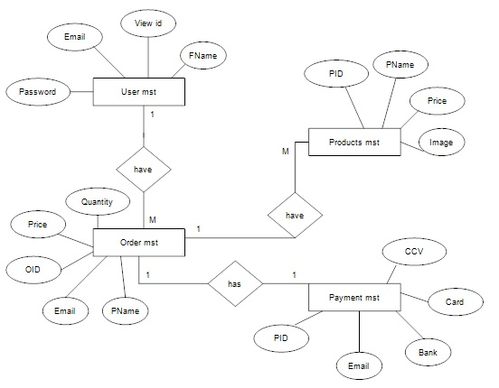

Figure 3.1: ER Diagram

**3.2 Data Flaw Diagram**

A Data Flow Diagram (DFD) is a graphical representation of the flow of data within a system. It illustrates how information moves between processes, data stores, and external entities. In the context of the Online Food Ordering website project, a DFD helps visualize the data flow and interactions between various components of the platform.

**Context level DFD – 0 level:**

The context level data flow diagram (DFD) is describing the whole system. The (o) level DFD describe the all-user module who operate the system. Below data flow diagram of online ordering site shows the two users can operate the system Admin and Member user. The Level 0 DFD provides an overview of the entire system, showing the high-level processes, data stores, and external entities involved in the Online Food Ordering website project.

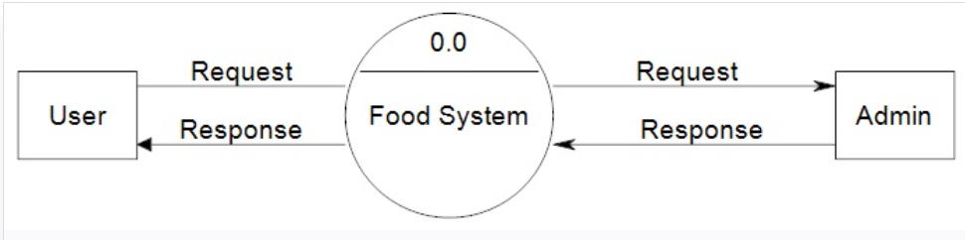

Figure 3.2: 0 level DFD

**1st level – User side Data flow Diagram**

The user is all people who operate or visit our website. User is a customer of a website. User can first select product for buy, user must have to register in our system for purchase any item from our website. This diagram aims to provide an in-depth understanding of how users interact with the platform, including actions such as browsing, searching, ordering, and managing their accounts.

**External Entities:**

1. **Guest User:** Represents individuals who visit the platform without creating an account.
2. **Registered User:** Users who have created an account and can access additional features like placing orders and leaving reviews.

**Processes:**

1. **Browse and Search Products:**

* **Subprocesses:**

**Browse Categories:** Allows users to navigate through different product categories.

**Search Products:** Enables users to search for specific products using keywords or filters.

**View Product Details:** Allows users to see detailed information about a selected product.

* **Data Flows:**

Data flows from the Browse Categories process to the View Product Details process, allowing users to select a category and view specific product details.

Data flows from the Search Products process to the View Product Details process, allowing users to select a product from search results and view detailed information.

1. **Manage Ordering Cart:**

* **Subprocesses:**

**Add to Cart:** Allows users to add products to their ordering cart.

**Update Cart:** Enables users to modify the quantity of items or remove them from the cart.

**View Cart:** Allows users to review the contents of their ordering cart.

* **Data Flows:**

Data flows from the Add to Cart process to the Update Cart process, allowing users to modify their ordering cart.

Data flows from the Add to Cart process to the View Cart process, allowing users to see the updated cart contents.

1. **Place Order:**

* **Subprocesses:**

**Select Shipping Address:** Users choose a shipping address for their order.

**Choose Payment Method:** Users select their preferred payment method.

**Confirm Order:** Users review their order details and confirm the purchase.

* **Data Flows:**

Data flows from the View Cart process to the Select Shipping Address process, carrying information about the selected products.

Data flows from the Select Shipping Address process to the Choose Payment Method process, including shipping details.

Data flows from the Choose Payment Method process to the Confirm Order process, carrying payment information.

1. **Manage User Account:**

* **Subprocesses:**

**Update Personal Information:** Allows users to modify personal details such as name, email, or password.

**View Order History:** Provides users with a summary of their previous orders.

**Logout:** Allows users to log out of their accounts.

* **Data Flows:**

Data flows from the View Order History process to the Update Personal Information process, allowing users to link order history to their account.

Data flows from the Update Personal Information process to the Logout process, ensuring updated information is reflected upon logout.

**Data Stores:**

1. **Product Database:** Stores information about products, including details like name, description, price, and inventory.
2. **Ordering Cart:** Temporarily holds information about products selected by the user for purchase.
3. **User Account Database:** Stores user-related information, including account details and order history.

**Data Flow Annotations:**

Data flows between processes and data stores are annotated with labels indicating the type of data being transferred. For example, product details, cart contents, shipping information, and user account information.

**System Boundary:**

The system boundary encapsulates the entire user side of the Online Food Ordering website project, illustrating the scope of user interactions and the flow of information within the platform.

The 1st Level User Side DFD provides a comprehensive overview of user-related processes, subprocesses, and the flow of data within the Online Food Ordering website project. It serves as a valuable tool for stakeholders, developers, and designers to understand the user experience and guide the development and implementation of the user interface and related functionalities. The diagram facilitates communication and collaboration among project stakeholders, ensuring a clear understanding of how users interact with the platform.

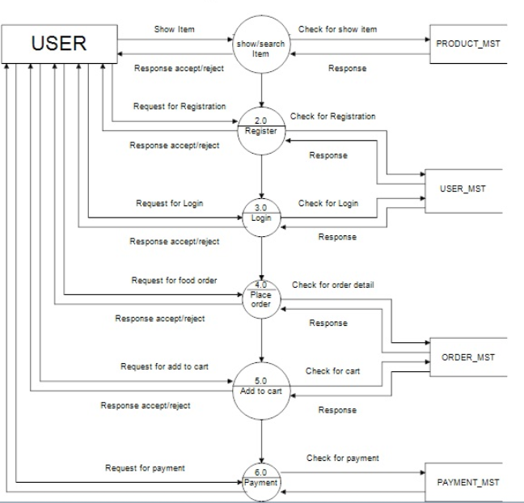

Figure 3.3: 1st level DFD

**2nd level – User side DFD:**

Creating a 2nd Level User Side Data Flow Diagram (DFD) for the Online Food Ordering website project involves further detailing the subprocesses identified in the 1st Level DFD. This level delves into the specific actions within each subprocess, breaking them down into more granular steps and illustrating the data flow between these steps. Let's explore the 2nd Level DFD for key subprocesses:

**Browse and Search Products:**

* **2nd Level Subprocesses:**

**Display Categories:** Retrieves and displays a list of available product categories for users to browse.

**Display Products by Category:** Based on the selected category, retrieves and displays a list of products within that category.

**Show Product Details:** Displays detailed information about a selected product.

* **Data Flows:**

Data flows from the Display Categories subprocess to the Display Products by Category subprocess, carrying information about available categories.

Data flows from the Display Products by Category subprocess to the Show Product Details subprocess, passing details about the selected product.

**Manage Ordering Cart:**

* **2nd Level Subprocesses:**

**Add Product to Cart:** Adds a selected product to the ordering cart.

**Update Cart Quantity:** Modifies the quantity of a product in the ordering cart.

**Remove Product from Cart:** Removes a product from the ordering cart.

* **Data Flows:**

Data flows from the Add Product to Cart subprocess to the Update Cart Quantity subprocess, updating the cart contents.

Data flows from the Add Product to Cart subprocess to the Remove Product from Cart subprocess, removing the selected product.

**Place Order:**

* **2nd Level Subprocesses:**

**Select Shipping Address:** Allows users to choose or add a shipping address for the order.

**Choose Payment Method:** Enables users to select a payment method for the order.

**Review Order:** Displays a summary of the selected products, shipping details, and payment information for user review before confirmation.

* **Data Flows:**

Data flows from the Select Shipping Address subprocess to the Choose Payment Method subprocess, passing shipping information.

Data flows from the Choose Payment Method subprocess to the Review Order subprocess, including payment details.

**Manage User Account:**

* **2nd Level Subprocesses:**

**Modify Personal Information:** Allows users to update their personal details.

**View Order Details:** Displays detailed information about a specific order.

**Logout:** Logs the user out of the account.

* **Data Flows:**

Data flows from the Modify Personal Information subprocess to the View Order Details subprocess, linking user information to specific order details.

Data flows from the Modify Personal Information subprocess to the Logout subprocess, ensuring updated information is reflected upon logout.

**Data Stores:**

* **Product Database:** Stores information about products, including details like name, description, price, and inventory.
* **Ordering Cart:** Temporarily holds information about products selected by the user for purchase.
* **User Account Database:** Stores user-related information, including account details and order history.

**Data Flow Annotations:**

Data flows between processes and data stores are annotated with labels indicating the type of data being transferred. For example, product details, cart contents, shipping information, and user account information.

**System Boundary:**

The system boundary encompasses the user side of the Online Food Ordering website project, illustrating the scope of user interactions and the flow of information within the platform.

The 2nd Level User Side DFD adds granularity to key subprocesses, providing a more detailed view of user interactions within the Online Food Ordering website project. It serves as a valuable guide for developers, designers, and stakeholders to understand the specific steps involved in each subprocess, facilitating a more nuanced approach to system development and user experience enhancement. The diagram enhances communication and collaboration among project stakeholders, ensuring a comprehensive understanding of user interactions and data flow within the platform.

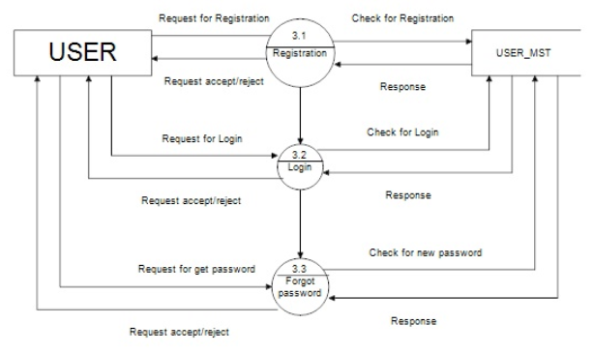

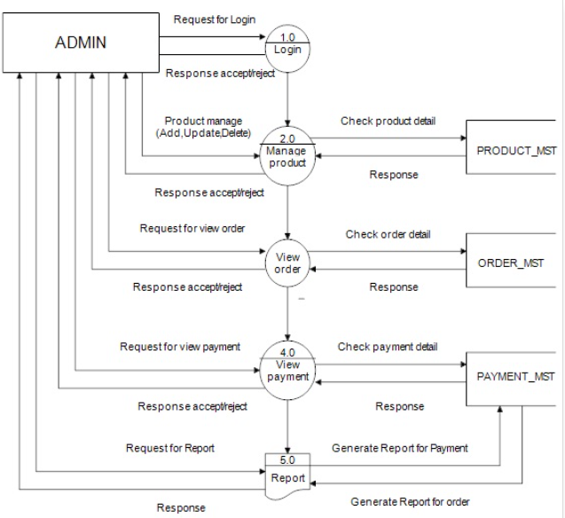Figure 3.4: 2nd level DFD (a)

Figure 3.5: 2nd level DFD (b)

**3.3 Use Case Diagram**

A Use Case Diagram is a visual representation that illustrates the interactions between different actors (users or external systems) and the functionalities of a system. In the context of the Online Food Ordering website project, a Use Case Diagram provides a high-level view of the various actions users can perform on the platform and how these actions relate to the system's functionalities.

**3.3.1 Actors:**

1. **Guest:** A guest represents a user who is not registered or logged into the platform. Guests have limited access to features such as browsing products, searching, and viewing product details.
2. **Registered User:** A registered user is an individual who has created an account on the platform. Registered users have additional privileges, including the ability to add items to the ordering cart, make purchases, and leave product reviews.
3. **Administrator:** The administrator is responsible for managing the platform, including overseeing user accounts, product listings, and resolving issues. Administrators have access to backend functionalities for system maintenance.

**3.3.2 Use Cases:**

1. **Browse Products:** Both guests and registered users can browse products available on the platform. This use case involves searching for products, viewing product details, and navigating through different categories.
2. **Search Products:** Users, whether guests or registered, can search for specific products based on keywords, categories, or other filters. The search functionality is essential for a seamless user experience.
3. **Add to Cart:** Registered users can add products to their ordering cart. This use case involves selecting items, specifying quantities, and managing the contents of the ordering cart.
4. **Make Purchase:** Registered users proceed to make a purchase by completing the checkout process. This use case includes entering shipping information, selecting payment methods, and confirming the order.
5. **Leave Review:** Registered users can leave reviews for products they have purchased. This use case involves rating the product and providing written feedback.
6. **Manage Account:** Registered users have the ability to manage their accounts by updating personal information, changing passwords, and viewing order history.

**3.3.3 Relationships:**

1. **Generalization:** There is a generalization relationship between the Guest and Registered User actors, indicating that a registered user is a specialized type of user compared to a guest.
2. **Association:** Both the Registered User and Guest actors are associated with all the primary use cases, such as browsing products, searching, and managing accounts. This reflects that these functionalities are accessible to both user types.
3. **Dependency:** The Administrator actor has a dependency relationship with all administrative use cases, indicating that these functionalities depend on the administrator's role.

**3.3.4 System Boundary:**

The system boundary defines the scope of the Online Food Ordering website project, delineating the interactions between actors and the system itself. It helps in visualizing the boundaries of the platform and clarifies the external entities that interact with it.

In conclusion, the Use Case Diagram for the Online Food Ordering website project provides a comprehensive overview of the interactions between different actors and the system's functionalities. It serves as a valuable tool for stakeholders, developers, and designers to understand the high-level features and user interactions within the platform. This diagram lays the foundation for detailed use case descriptions and further system development.

A use case diagram is a type of diagram in the Unified Modelling Language (UML) that is used to visualize and describe the functional requirements of a system from an external user's perspective. It provides a high-level view of how users interact with a system and the various functionalities or use cases the system offers in response to those interactions.

Use case diagrams are particularly useful for:

* Communicating the system's functionality and behaviour to stakeholders in a visual and understandable way.
* Capturing and documenting high-level user requirements.
* Identifying system boundaries and external interactions.
* modelling how different use cases relate to each other.

They are a valuable tool in the early stages of software development for understanding and discussing the functional aspects of a system before diving into more detailed design and implementation phases.

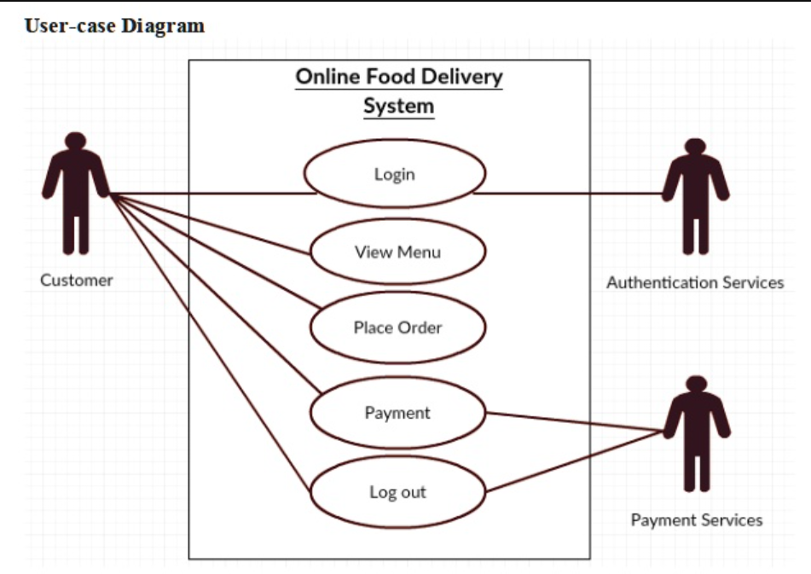

Figure 3.6: Use Case Diagram

**CHAPTER 4**

**DESIGN**

**4.1 Login Module**

Login module plays a pivotal role in providing a secure and user-friendly entry point for individuals using the Online Food Ordering website. By focusing on robust authentication, security measures, and seamless integration with other modules, this module contributes to a positive user experience and helps establish trust in the platform.

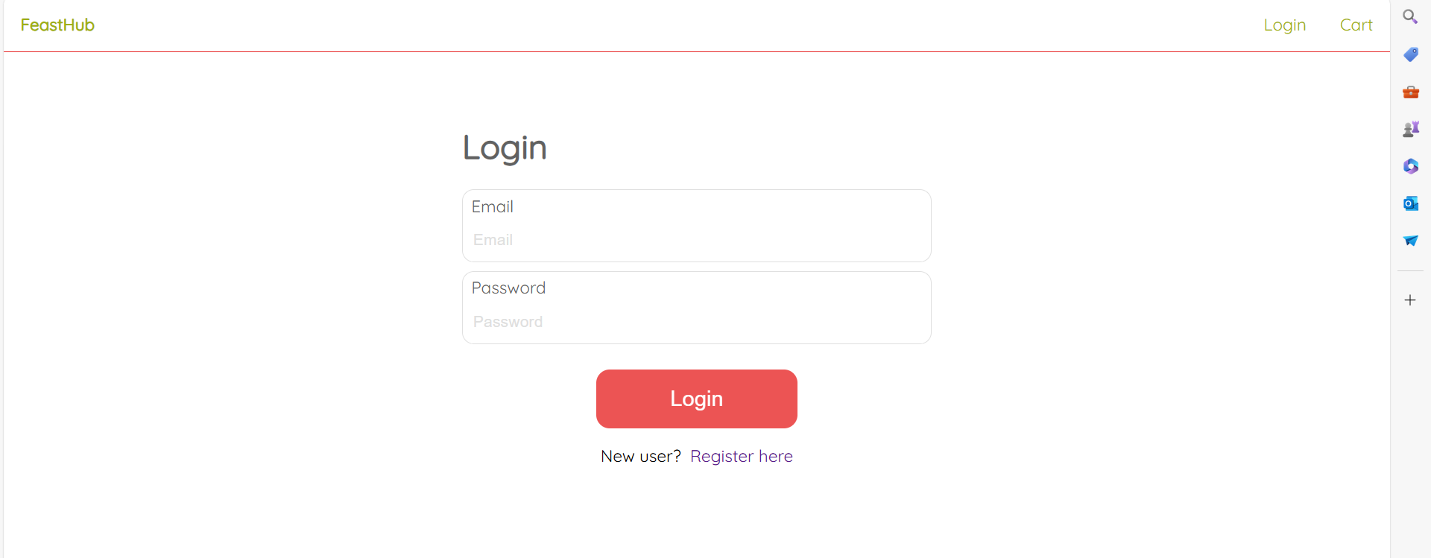

Figure 4.1 Login

**4.2 New Register Module**

Register module plays a pivotal role in the overall user on boarding experience within the Online Food Ordering website project. By incorporating user-friendly interfaces, robust security measures, and seamless integration with other modules, it contributes to creating a positive first impression and establishing a secure foundation for user interactions with the platform.

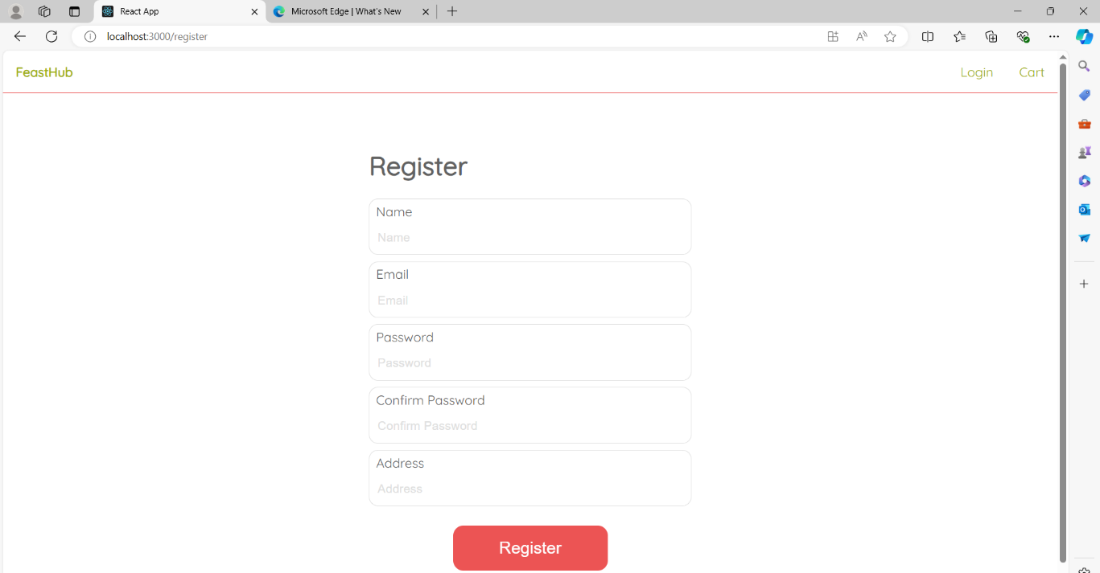

Figure 4.2 New User Register

**4.3 Home Page**

The homePage module of the Online Food Ordering website project plays a pivotal role in shaping the user's first impression, fostering engagement, and driving conversions. By combining visually appealing design with intuitive navigation and personalized recommendations, the Home Page sets the tone for a positive user experience and encourages users to explore the diverse range of products offered on the platform.

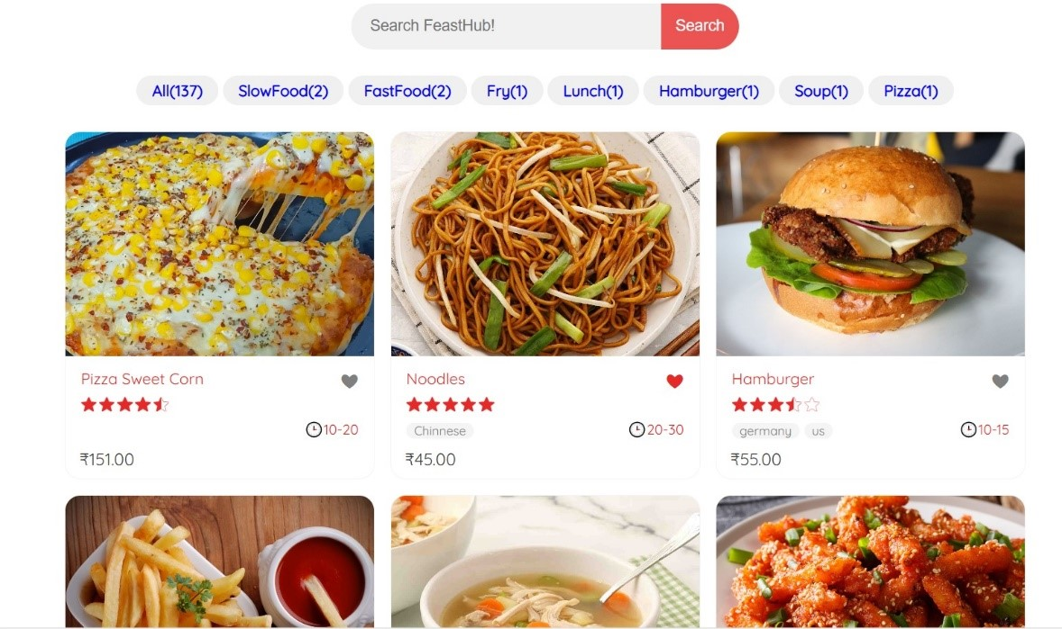

Figure 4.3 Home Page

**4.4 Categories module**

Manage Restaurant Module is a cornerstone of the Online Food Ordering website project, providing a rich and interactive experience for users exploring and considering a purchase. By focusing on usability, dynamic content, security, and integration with other modules, this component contributes significantly to the overall success of the platform. The module not only serves the functional purpose of conveying product details but also plays a crucial role in shaping the user's perception and engagement with the online Restaurant experience.

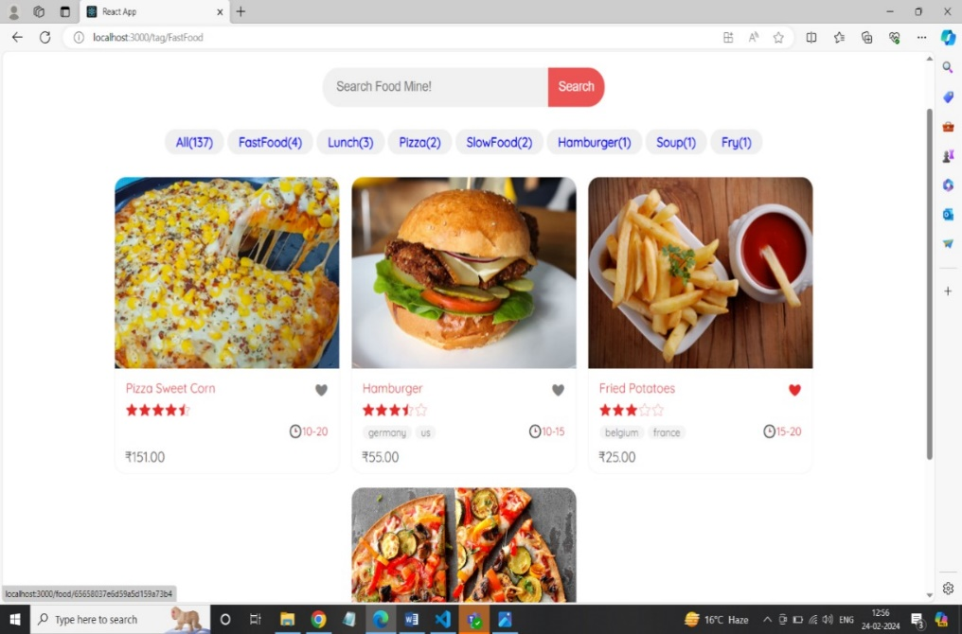

Figure 4.4 Categories

**4.5 Add Cart Module**

The Cart module enables users to add items to their shopping cart, view selected products, and manage quantities. Users can remove items, update quantities, and save their cart for future purchases. This module also facilitates seamless navigation to the checkout process, ensuring a smooth and efficient shopping experience.

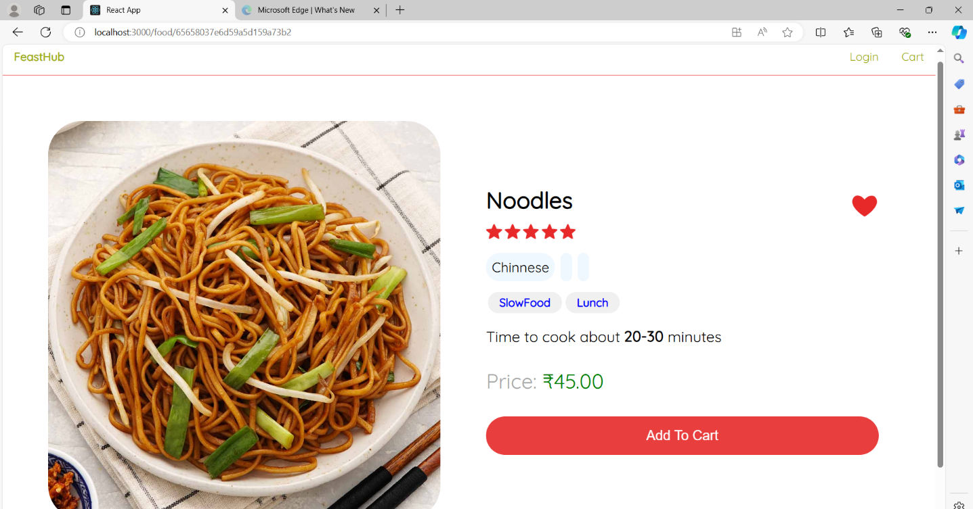

Figure 4.5 Cart

**4.6 Order Status Module**

The Order Status Module in the Online Food Ordering website project is a critical component that enhances the user ordering experience. It provides a user-friendly interface for managing and reviewing selected products, calculates the total cost, and seamlessly integrates with other modules like the Checkout Module. By offering features such as saving items for later and persisting cart data for registered users, the Order Module contributes to a comprehensive.

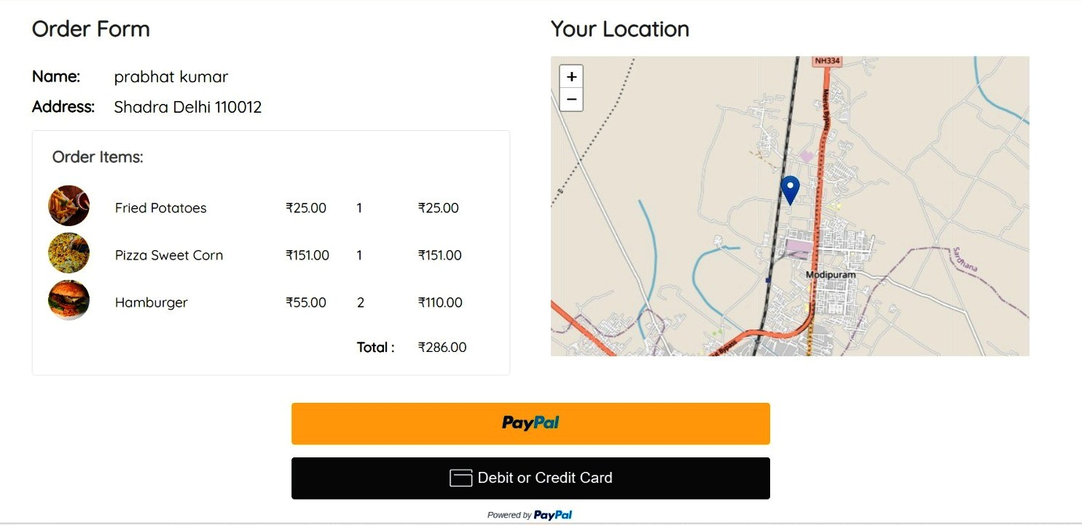

Fig 4.6 Order and Payment

**4.7 Profile Management**

The Profile Management module enables users to create and update their personal information, manage delivery addresses, and view order history. It also allows users to set preferences, save favorite restaurants, and manage payment options, ensuring a personalized, efficient, and seamless food delivery experience tailored to their needs and preferences.

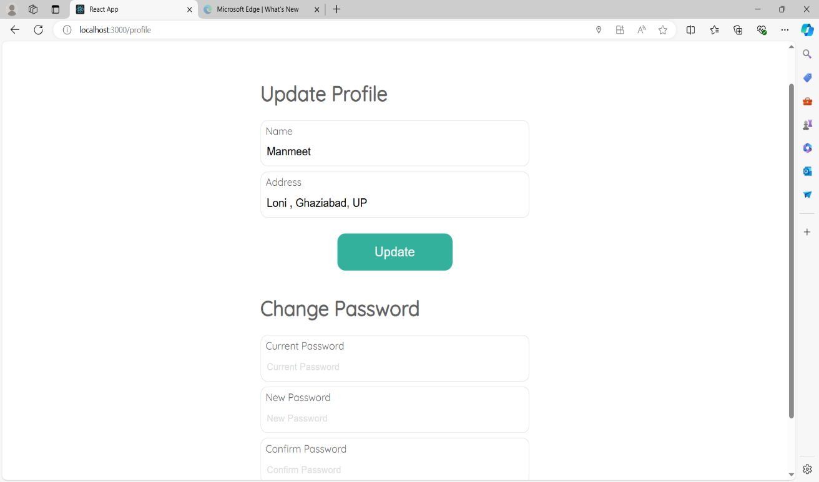

Figure 4.7 Profile Management

**4.8 Payment Module**

Implement a secure payment module using Stripe for the food ordering website. Integrate Stripe API to handle payments, ensuring SSL encryption for transactions. Allow users to pay via credit/debit cards and digital wallets. Include order confirmation and error handling. Ensure compliance with PCI DSS standards for secure payment processing and store minimal sensitive information. 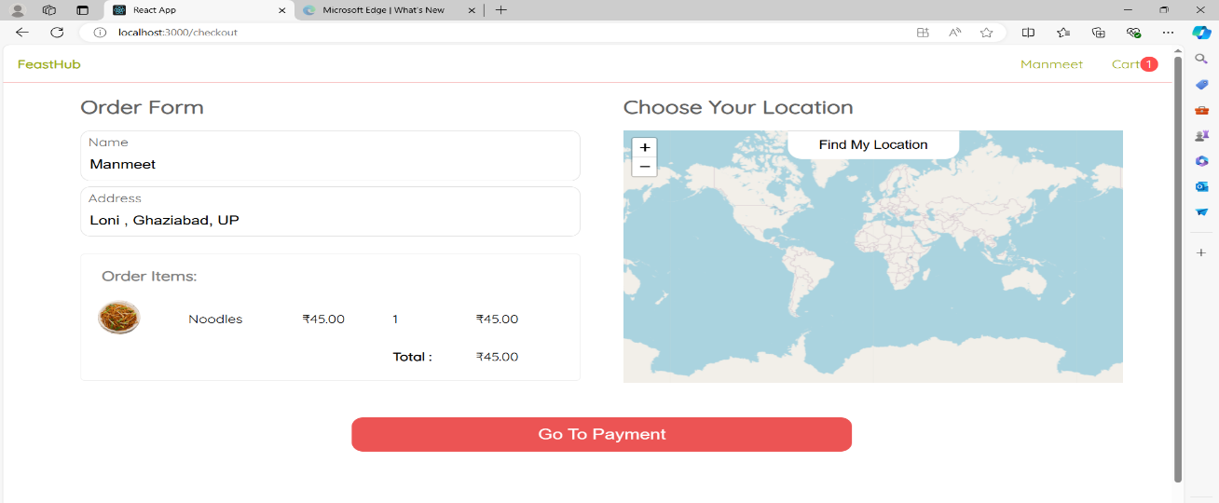

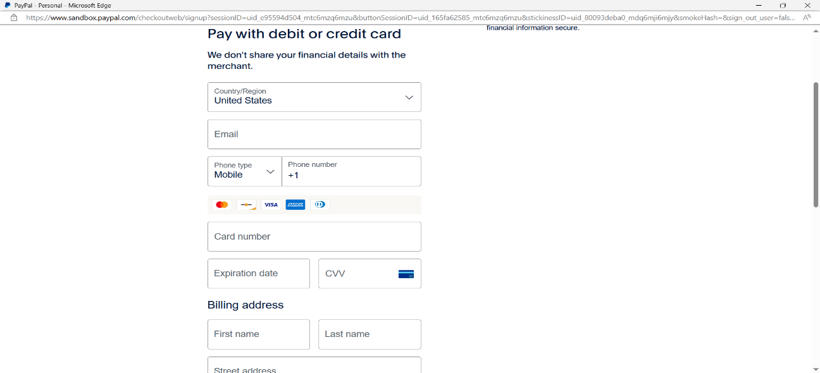

Figure 4.8 Payment

**4.9 Database Schema**

This MongoDB database schema for the Online Food Ordering website project provides a flexible and scalable structure to handle user accounts, product listings, orders, reviews, and categories. The use of ObjectId references establishes relationships between collections, and the document-oriented model allows for efficient querying and retrieval of data. Developers can further enhance this schema based on specific project requirements and performance considerations.

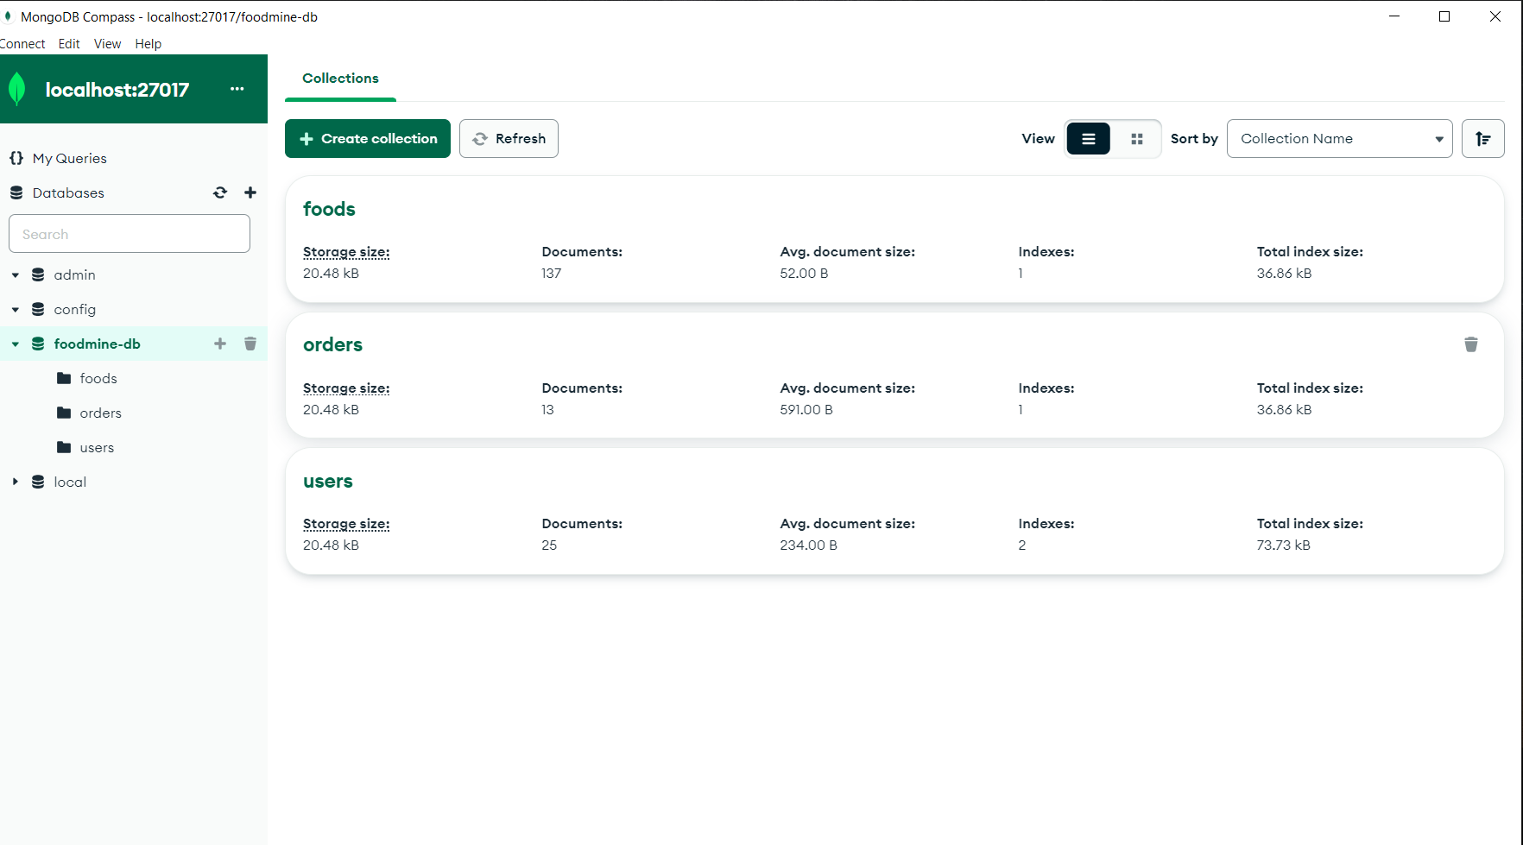

Figure 4.9 Database

**4.10 Foods Collection Screenshot**

The food collection in MongoDB stores details of menu items, including names, descriptions, prices, ingredients, and categories, enabling efficient retrieval and management for the food delivery website**.**

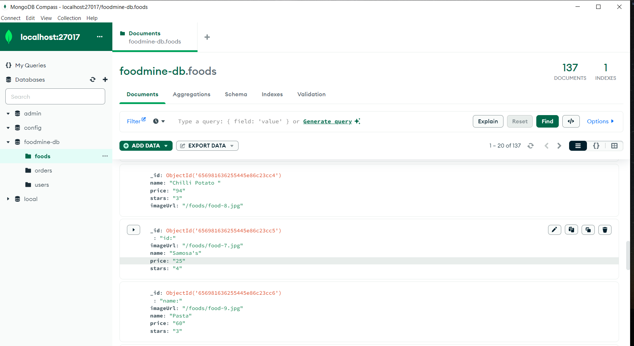

Figure 4.10 Foods Collection

**4.11 Orders Collection Screenshot**

The Order Collection in MongoDB stores customer orders, including item details, quantities, prices, delivery addresses, and status, ensuring efficient management and retrieval of order information for seamless food delivery.

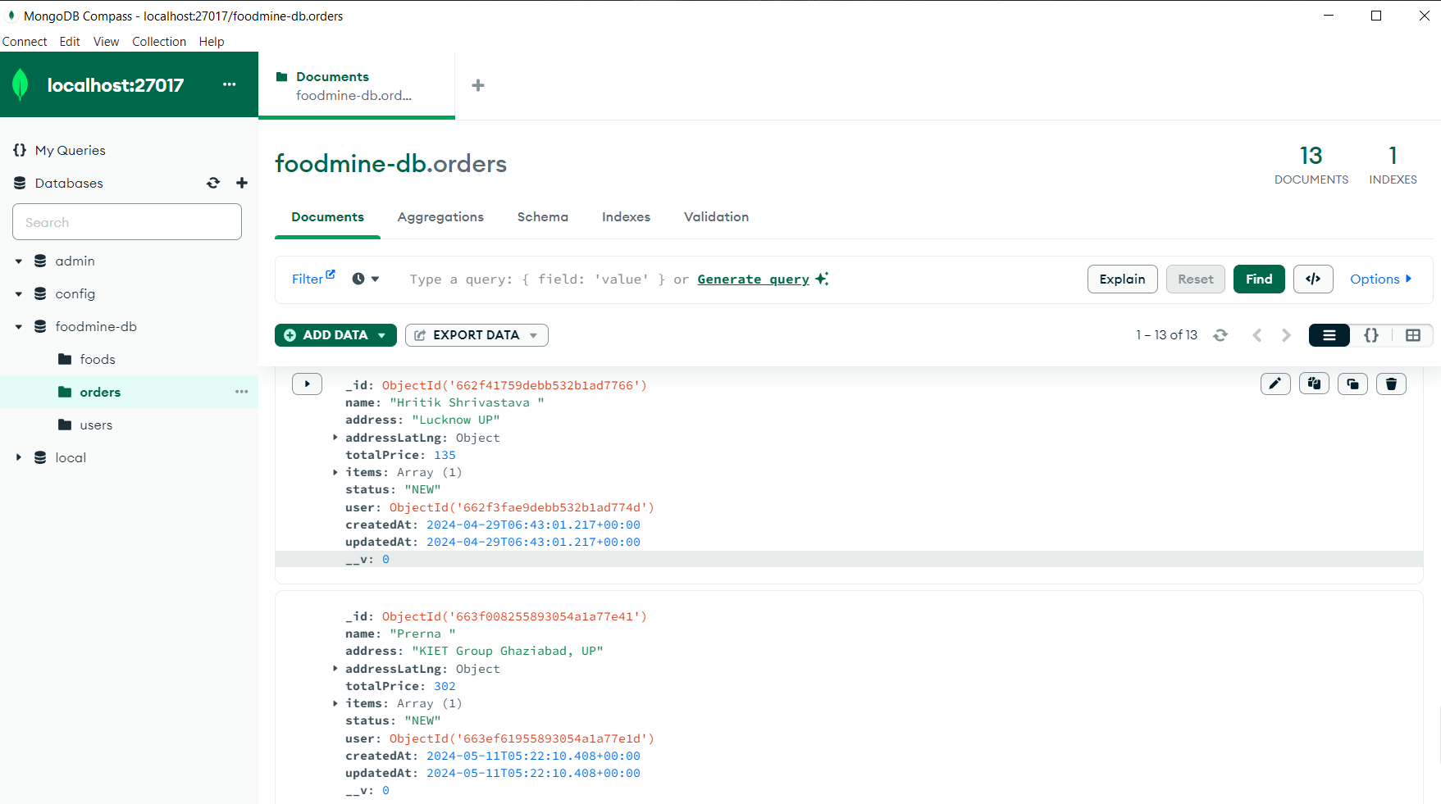

Figure 4.11 Orders Collection

**4.12 User Collection Screenshot**

The User collection in MongoDB stores user data including personal details, delivery addresses, order history, and preferences, ensuring efficient data retrieval and management for a personalized food delivery experience**.**

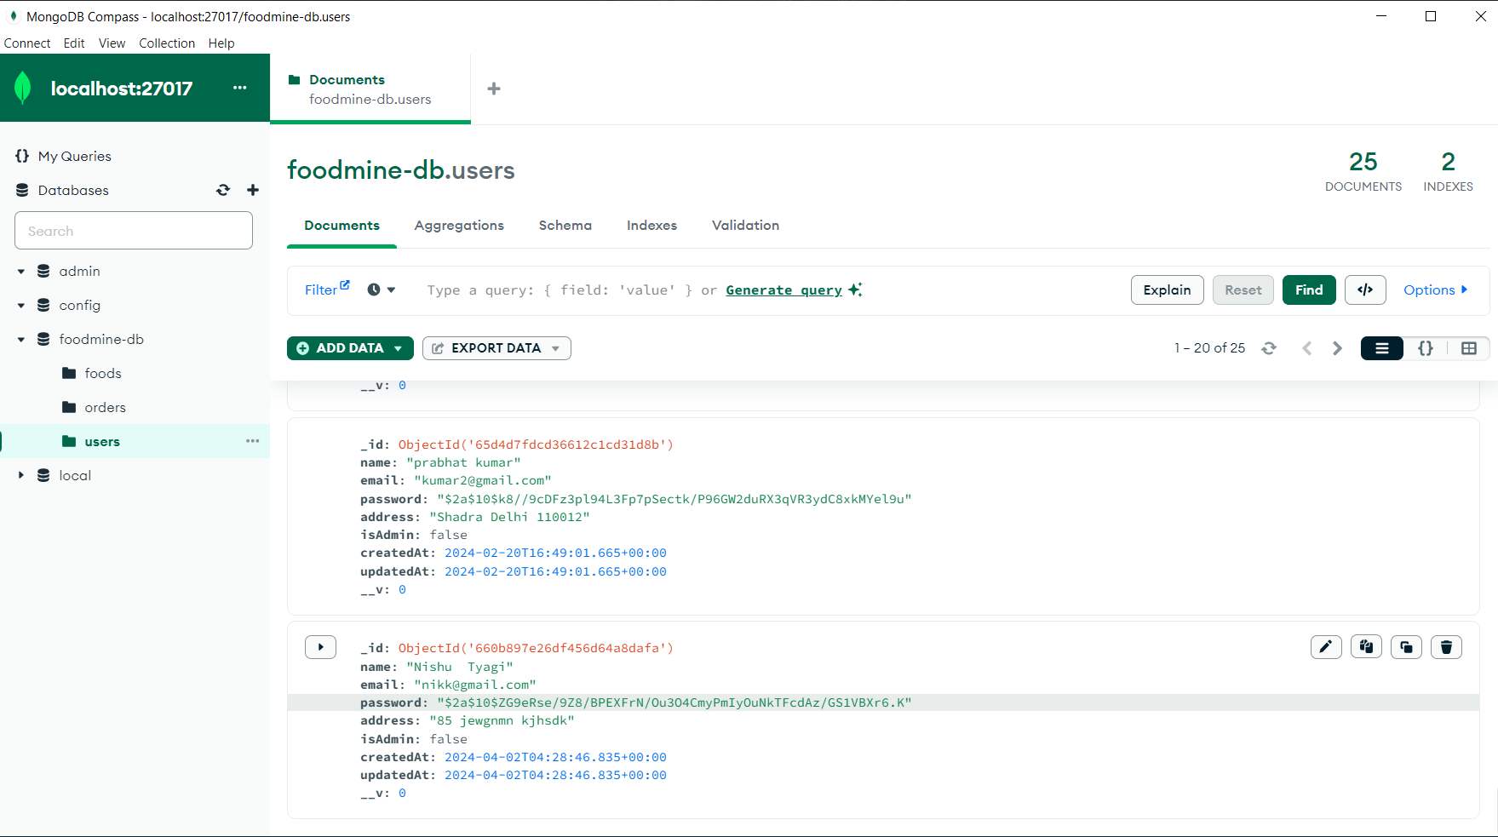

Figure 4.12 User Collection

**CHAPTER 5**

**DISCUSSIONS**

The discussions section of an Online Food Ordering website project is crucial for presenting and analysing various aspects of the project. This section typically covers the project's challenges, decisions made during the development process, potential improvements, and considerations for future enhancements. Here's a comprehensive discussion of the Online Food Ordering website project:

**5.1 Challenges Faced:**

Developing a food ordering website presented several challenges, both technical and logistical. A primary issue was ensuring a seamless user experience across various devices and browsers. Achieving a responsive design that catered to different screen sizes without compromising functionality required extensive testing and iteration.

Data security was another significant concern. Safeguarding users' personal information and payment details necessitated the implementation of robust encryption protocols and secure payment gateways. Ensuring compliance with regulations such as GDPR added another layer of complexity.

Integration with existing restaurant management systems posed additional hurdles. Each system had its own API specifications and data formats, necessitating customized solutions for smooth data exchange. Coordinating with multiple restaurants to keep their menus, pricing, and availability updated in real-time was a logistical challenge, often requiring manual interventions.

Performance optimization was crucial to handle high traffic volumes, particularly during peak meal times. Implementing efficient database queries and caching strategies was essential to minimize load times and prevent server overloads.

* 1. **Decisions Made:**

To tackle these challenges, several key decisions were made. Firstly, adopting a mobile-first approach ensured that the website was fully optimized for smartphones, reflecting the predominant use case for food ordering. Using responsive web design techniques, the layout dynamically adjusted to different screen sizes.

For data security, we integrated HTTPS protocols and partnered with a reputable payment gateway to manage transactions securely. User authentication was reinforced with multi-factor authentication, and sensitive data was encrypted both in transit and at rest. We chose to develop a modular architecture that allowed for easier integration with various restaurant management systems. This decision enabled us to create custom adapters for each system, facilitating smooth data flow and reducing the need for extensive manual updates.

To address performance issues, we implemented server-side rendering (SSR) and used a content delivery network (CDN) to deliver static assets efficiently. Database indexing and query optimization were prioritized to ensure quick data retrieval.

* 1. **Potential Improvements:**

Despite the successful implementation of the website, several areas for improvement were identified. Enhancing the user interface (UI) to make it more intuitive and engaging could significantly improve user satisfaction. Incorporating user feedback through continuous usability testing would help identify pain points and areas for enhancement. Improving the scalability of the system is another potential area. While the current infrastructure handles peak loads reasonably well, adopting microservices architecture could further enhance scalability and fault tolerance, ensuring the system remains robust under increasing traffic.

Another improvement could be the introduction of advanced analytics. By leveraging machine learning algorithms, the website could offer personalized recommendations to users based on their order history and preferences, potentially increasing user engagement and sales.

* 1. **Future Enhancements:**

Looking ahead, several future enhancements are planned to elevate the functionality and user experience of the food ordering website. Implementing a chatbot powered by artificial intelligence (AI) for customer service can provide immediate assistance to users, improving response times and overall customer satisfaction. Introducing a loyalty program could also incentivize repeat business. By rewarding users with points for each order, which can be redeemed for discounts or free items, we can foster customer loyalty and increase order frequency.

Another enhancement involves expanding the delivery tracking system. Integrating real-time GPS tracking for deliveries would provide users with accurate, up-to-the-minute updates on their orders, enhancing transparency and trust.

Lastly, expanding the website’s multilingual capabilities would cater to a broader audience. By supporting multiple languages, we can make the website accessible to non-English speaking users, thereby expanding our user base and improving inclusivity.

In conclusion, while the food ordering website project overcame significant challenges through strategic decisions, continuous improvement and forward-thinking enhancements will be essential to maintain its competitiveness and user satisfaction in a rapidly evolving digital landscape.

**CHAPTER 6**

**TESTING**

**6.1 INTRODUCTION**

In the dynamic landscape of food ordering website, creating a seamless and robust online ordering experience is paramount. The development of a food ordering website project requires a meticulous and comprehensive testing strategy to ensure the functionality, performance, and reliability of the platform. Testing is a crucial phase in the software development life cycle, and it plays a pivotal role in identifying and rectifying potential issues before the application is deployed. In this context, three essential types of testing:

1. Unit Testing,
2. Integration Testing and
3. System Testing

form the cornerstone of quality assurance for the Online Food Ordering website project.

**6.2 TYPES OF TESTING**

**6.2.1 Unit Testing**

Unit Unit testing involves testing individual components of the website to ensure that each part functions correctly in isolation. For a food ordering website, the focus areas include:

1. **User Authentication Module**:
   * **Test Case 1**: Verify that the user can register with valid credentials.
     + **Input**: Valid username, email, password.
     + **Expected Output**: Successful registration message.
   * **Test Case 2**: Verify login with correct credentials.
     + **Input**: Correct username and password.
     + **Expected Output**: User is redirected to the dashboard.
   * **Test Case 3**: Verify login with incorrect credentials.
     + **Input**: Incorrect username or password.
     + **Expected Output**: Error message indicating invalid credentials.
2. **Menu Management Module**:
   * **Test Case 1**: Verify that an admin can add a new menu item.
     + **Input**: Valid item name, description, price, and category.
     + **Expected Output**: Menu item is added and displayed on the menu.
   * **Test Case 2**: Verify that an admin can update an existing menu item.
     + **Input**: Valid updates to item name, description, price.
     + **Expected Output**: Changes are saved and reflected on the menu.
   * **Test Case 3**: Verify that an admin can delete a menu item.
     + **Input**: Item ID.
     + **Expected Output**: Menu item is removed from the menu.
3. **Order Processing Module**:
   * **Test Case 1**: Verify that a user can place an order with selected items.
     + **Input**: Selected menu items and quantities.
     + **Expected Output**: Order is created and confirmation is shown.
   * **Test Case 2**: Verify that order details are saved correctly.
     + **Input**: Specific order details.
     + **Expected Output**: Details match the order record in the database.

**6.2.2. Integration Testing**

As Integration testing focuses on testing the interactions between integrated units/modules to ensure they work together as expected. For the food ordering website, the integration points include:

1. **User Authentication and Profile Management**:
   * **Test Case**: Verify that a user can log in and view/edit their profile.
     + **Input**: User logs in and navigates to the profile section.
     + **Expected Output**: Profile information is correctly retrieved and updates are saved.
2. **Menu Display and Order Placement**:
   * **Test Case**: Verify that users can view the menu and place orders seamlessly.
     + **Input**: User browses the menu and adds items to the cart.
     + **Expected Output**: Items are added to the cart and an order can be placed successfully.
3. **Payment Gateway Integration**:
   * **Test Case**: Verify that payment processing works correctly.
     + **Input**: User places an order and proceeds to payment.
     + **Expected Output**: Payment is processed, and order confirmation is received.
4. **Order Management and Notification System**:
   * **Test Case**: Verify that users receive notifications after placing an order.
     + **Input**: User completes an order.
     + **Expected Output**: Notification (email/SMS) is sent with order details.

**6.2.3 System Testing**

System testing is the process of testing the complete and fully integrated software to evaluate the system's compliance with its specified requirements. This includes functional and non-functional testing aspects.

1. **Functional Testing**:
   * **Test Case**: Verify end-to-end functionality from user registration to order completion.
     + **Input**: New user registration, menu browsing, order placement, payment.
     + **Expected Output**: Each step is completed successfully without errors.
2. **Performance Testing**:
   * **Test Case**: Assess the website's performance under various load conditions.
     + **Input**: Simulate multiple users browsing and placing orders simultaneously.
     + **Expected Output**: Website remains responsive and handles the load without significant slowdowns or crashes.
3. **Security Testing**:
   * **Test Case**: Evaluate the system's resilience to security threats.
     + **Input**: Attempt various security breaches (e.g., SQL injection, XSS).
     + **Expected Output**: System is protected against common security threats and vulnerabilities.
4. **Usability Testing**:
   * **Test Case**: Ensure the website is user-friendly and intuitive.
     + **Input**: Real users perform typical tasks like registering, browsing the menu, and ordering.
     + **Expected Output**: Users find the website easy to navigate and use.
5. **Compatibility Testing**:
   * **Test Case**: Verify the website works across different browsers and devices.
     + **Input**: Access the website using various browsers (Chrome, Firefox, Safari) and devices (mobile, tablet, desktop).
     + **Expected Output**: Website functions correctly across all tested platforms.

In conclusion, comprehensive testing through Unit Testing, Integration Testing, and System Testing ensures that the food ordering website functions correctly, integrates well, and provides a seamless user experience. Each type of testing addresses specific aspects of the application, from individual components to the entire system, ensuring a robust and reliable final product.

**CHAPTER 7**

**CONCLUSION**

The development and implementation of a food ordering website is a multifaceted endeavour that necessitates careful consideration of various technical, financial, operational, and risk-related factors. This project aimed to create a robust, user-friendly, and secure platform for food ordering, addressing the needs of both customers and restaurant partners. Our analysis and implementation strategies have led to several key conclusions in the domains of technical aspects, financial considerations, operational viability, risk analysis and mitigation, and overarching recommendations.

* 1. **Technical Aspects:**

From a technical standpoint, the project's success hinged on the adoption of a modern and scalable tech stack. We employed a combination of front-end technologies such as HTML5, CSS3, and JavaScript frameworks like React.js, along with back-end solutions using Node.js and Express.js. The database management relied on MongoDB for its flexibility and scalability. Key features such as real-time order tracking, secure payment gateways, and responsive design were prioritized to enhance user experience and security.

Moreover, the integration of APIs for payment processing, location services, and push notifications ensured that the platform remained functional and user-centric. Robust testing protocols, including unit testing, integration testing, and user acceptance testing, were implemented to identify and rectify potential issues before deployment. This comprehensive technical foundation guarantees that the platform can handle high traffic volumes, maintain data integrity, and provide a seamless user experience.

**7.2 Financial Considerations:**

The Financial analysis of the project highlighted the importance of initial capital investment, ongoing operational costs, and revenue generation strategies. Initial costs were primarily associated with web development, server infrastructure, and marketing. Operational costs, including server maintenance, customer support, and regular updates, were factored into the financial model.

Revenue streams were projected from multiple sources: commission fees from restaurant partners, delivery charges, and premium listing fees for restaurants. A break-even analysis indicated that the platform could become profitable within the first year, assuming a moderate adoption rate and efficient marketing strategies. Additionally, the financial model considered scalability, ensuring that increased user adoption would proportionally increase revenue without disproportionately increasing costs.

**7.3 Operational Viability:**

Operational viability was assessed through a detailed examination of the logistics involved in food ordering and delivery. Key operational components included the establishment of partnerships with local restaurants, integration with reliable delivery services, and a robust customer support system. The platform’s operational framework was designed to ensure timely order processing, accurate delivery, and high customer satisfaction.

Effective use of data analytics was recommended to monitor performance, optimize delivery routes, and manage inventory. This data-driven approach allows for continuous improvement in operational efficiency and customer service. Additionally, training programs for restaurant partners and delivery personnel were proposed to ensure consistent service quality.

**7.4 Risk Analysis and Mitigation:**

Risk analysis identified potential challenges such as cybersecurity threats, technical failures, market competition, and legal compliance issues. Cybersecurity measures, including encryption, regular security audits, and compliance with data protection regulations, were essential to protect user data and build trust.

Technical risks were mitigated through the implementation of failover systems, regular backups, and a robust disaster recovery plan. Competitive risks were addressed by focusing on unique value propositions, such as superior user experience, exclusive restaurant partnerships, and innovative features like AI-driven recommendations. Legal risks were managed by ensuring compliance with food safety regulations, e-commerce laws, and privacy policies.

**7.5 Recommendation:**

Based on the comprehensive analysis, several recommendations were made to ensure the long-term success of the food ordering platform:

1. **Continuous Improvement and Innovation**: Regularly update the platform with new features and improvements based on user feedback and technological advancements.
2. **Scalable Infrastructure**: Invest in scalable server infrastructure to handle peak traffic and expand into new markets without compromising performance.
3. **Strategic Partnerships**: Form strategic alliances with local and national restaurants, delivery services, and technology providers to enhance service offerings.
4. **Marketing and Customer Acquisition**: Implement targeted marketing campaigns to attract and retain customers, leveraging social media, SEO, and promotional offers.
5. **Focus on Customer Experience**: Prioritize customer service and support to address issues promptly and enhance user satisfaction and loyalty.
6. **Regulatory Compliance**: Stay updated with regulatory changes and ensure ongoing compliance to avoid legal complications.
7. **Data Security**: Continuously invest in cybersecurity measures to protect user data and maintain trust.

In conclusion, the food ordering website project is poised for success given the thorough consideration of technical, financial, and operational factors. With proactive risk management and a focus on continuous improvement, the platform can achieve sustainable growth and become a leader in the online food ordering industry.

**CHAPTER 8**

**BIBILIOGRAPHY**

[1] Introduction to HTML CSS JavaScript from W3Schools

<https://www.w3schools.com/html/>

<https://www.w3schools.com/css/>

<https://www.w3schools.com/js/>

[2] Introduction to MongoDb from javatpoint

<https://www.javatpoint.com/mongodb-tutorial>

[3] Concept of react by reactjs tutorial

<https://legacy.reactjs.org/tutorial/tutorial.html>

[4] NodeJs by W3Schools

<https://www.w3schools.com/nodejs/>